LUXE HAVEN

22ITP61-PROJECT REPORT
Submitted by

ASWATH SIVA K M (23ITR010)
ASWIGA P (23ITR011)

in partial fulfilment of the
requirements for the award of the degree of

BACHELOR OF TECHNOLOGY IN
INFORMATION TECHNOLOGY

DEPARTMENT OF INFORMATION TECHNOLOGY


KONGU ENGINEERING COLLEGE
(Autonomous)
PERUNDURAI ERODE – 638 060
MARCH 2026

DEPARTMENT OF INFORMATION TECHNOLOGY KONGU ENGINEERING COLLEGE

(Autonomous)
PERUNDURAI ERODE – 638060
MARCH 2026

BONAFIDE CERTIFICATE

This is to certify that the Project report entitled “E-Commerce App LUXE HAVEN ” is the Bonafide record of project work done by ASWATH SIVA K M (23ITR010) and ASWIGA P (23ITR011) in partial Fulfillment of the requirements for the award of the Degree of Bachelor of Technology in INFORMATION TECHNOLOGY of Anna University Chennai during the year 2025 - 2026.

SUPERVISOR HEAD OF THE DEPARTMENT

Date: (Signature with seal)

Submitted for the end semester viva voce examination held on .

INTERNAL EXAMINER EXTERNAL EXAMINER

DEPARTMENT OF INFORMATION TECHNOLOGY KONGU ENGINEERING COLLEGE

(Autonomous)
PERUNDURAI ERODE – 638060
MARCH 2026

DECLARATION

We affirm that the Project Report titled “ E-Commerce App LUXE HAVEN ” being submitted in partial Fulfillment of the requirements for the award of Bachelor of Technology is the original work carried out by us. It has not formed the part of any other project report or dissertation on the basis of which a degree or award was conferred on an earlier occasion on this or any other candidate.

ASWATH SIVA K M
(23ITR010)

ASWIGA P
(23ITR011)

I certify that the declaration made by the above candidates is true to the best of my knowledge.

Date: Name and Signature of the Supervisor with seal

ABSTRACT

Luxe Haven is a cutting-edge e-commerce mobile application designed to transform the luxury retail landscape by delivering an unparalleled online shopping experience. The platform empowers customers to effortlessly browse premium products, curate wishlists, manage shopping carts, and complete secure transactions, while providing businesses with sophisticated tools for inventory management, order processing, and customer engagement. Through this digital solution, Luxe Haven bridges the divide between traditional luxury retail and modern e-commerce, enabling seamless 24/7 access to high-end fashion and lifestyle products.

A key highlight of the system is its robust Razorpay payment integration, ensuring swift, secure, and reliable financial transactions that build customer trust. The application features a comprehensive admin dashboard offering real-time insights into inventory levels, order statuses, sales analytics, and customer behavior. This dual-benefit approach enhances the customer journey with intuitive navigation and personalized experiences, while equipping businesses with data driven tools to optimize operations and drive revenue growth.

Built on a scalable architecture, Luxe Haven is poised for future expansions including multi-vendor support, advanced analytics, loyalty programs, and AI-powered recommendations. These planned enhancements will further amplify the platform's value, positioning it as an indispensable tool for luxury brands seeking sustainable growth.

In essence, Luxe Haven represents a forward-thinking approach to luxury e-commerce, blending elegant design with powerful functionality. By harnessing mobile technology, the application not only delivers immediate operational efficiencies and enhanced customer satisfaction but also lays the groundwork for long-term digital excellence in the competitive luxury marketplace. This project exemplifies how traditional retail sectors can embrace innovation to create exceptional shopping experiences and achieve lasting success in the digital era.

ACKNOWLEDGEMENT

First and foremost, we acknowledge the abundant grace and presence of Almighty throughout different phases of the project and its successful completion.

We express our gratefulness to Correspondent THIRU. E. R. K. Krishnan, M.Com. and all the trust members of Kongu Vellalar Institute of Technology Trust for providing all the necessary facilities to complete the project successfully.

We express our deep sense of gratitude to our beloved Principal Dr.R.Parameshwaran M.E.,Ph.D., for providing us an opportunity to complete the project.

We express our gratitude to Dr. S. Anandamurugan M.E.,Ph.D., Head of the Department, Department of Information Technology for his valuable suggestions.

We are thankful to our Project Coordinators Dr.E.M.Roopa Devi M.E,Ph.D., Ms.S.Sujitha M.Tech and G.Sasikala M.E., for their valuable guidance and support.

We are highly indebted to Mr.A.P.Ponselvakumar ME., Department of Information Technology for his valuable supervision and advice for the fruitful completion of the project.

We are thankful to the faculty members of the Department of Information Technology for their valuable guidance and support.

We are obliged to thank Mr.S.HARISHWA, Owner of (LUXE HAVEN) for supporting us through the various development phases of the project with atmost trust.

TABLE OF CONTENTS

CHAPTER No. TITLE PAGE No.

ABSTRACT | iv
LIST OF FIGURES | viii
LIST OF ABBREVIATIONS | ix
1 INTRODUCTION | 1
1.1 OVERVIEW | 1
1.2 OBJECTIVE | 1
2 SYSTEM SPECIFICATION | 2
2.1 HARDWARE REQUIREMENTS | 2
2.2 SOFTWARE REQUIREMENTS | 2
- SYSTEM DESIGN  - MODULES DESCRIPTION  - User Authentication Module  - Project Management Module  - Product Browsing and Search Module  - Project and Task Viewing Module  - API and Backend Processing Module  - Database Management Module  - User Interface Module | 3  3  3  3  4  4  4  5  6  6

- RESULTS 7
- CONCLUSION 8
APPENDIX 1- CODING 9
REFERENCES 26

LIST OF FIGURES

FIGURE No. | FIGURE NAME | PAGE No.
1.1 | LOGIN PAGE | 3
1.2 | CREATE PROJECT PAGE | 4
1.3 | EDIT TASK PAGE | 4
1.4 | PROJECT AND TASK VIEWING PAGE | 5
1.5 | APIs USED | 5
1.6  1.7 | BACKEND PAGE  DASHBOARD PAGE | 6  6

LIST OF ABBREVIATIONS

Abbreviation | Full Form
CSS | Cascading Style Sheets
C | C Programming Language
HTML | HyperText Markup Language
ID | Identifier
JS | JavaScript
JSX | JavaScript XML
QR | Quick Response (Code)
URL | Uniform Resource Locator
AI | Artificial Intelligence
API | Application Programming Interface
HTTP | HyperText Transfer Protocol
AJAX | Asynchronous JavaScript and XML
I/O | Input / Output
JSON | JavaScript Object Notation
JWT | JSON Web Token

CHAPTER 1

INTRODUCTION

  - OVERVIEW

The escalating need for digital transformation in the retail industry has underscored the importance of adopting agile and scalable solutions to manage modern commerce operations. This project centers on creating a mobile-based e-commerce application tailored for Luxe Haven, designed to optimize product sales, inventory management, and customer interactions. The platform empowers users to explore luxury fashion and lifestyle products, manage wishlists, place orders, and execute secure payments via an integrated gateway, while enabling administrators to oversee stock levels and track transactions in real time. Through the automation of core business processes, this solution diminishes manual efforts, curtails inaccuracies, and boosts overall operational productivity. It establishes a foundation for sustained growth, superior customer service, and seamless integration with cutting-edge retail technologies.

OBJECTIVE

- To create a robust e-commerce mobile application for Luxe Haven that facilitates streamlined product sales, inventory oversight, and customer engagement.

- To incorporate real-time product updates, secure payment processing (via Razorpay), and an intuitive user interface to elevate the shopping journey.

- To enhance business performance by automating transactions and delivering a reliable, secure environment for both customers and administrators.

CHAPTER 2

SYSTEM SPECIFICATION

  - HARDWARE REQUIREMENTS

Processor : Intel Pentium

Processor Speed : 250MHz to 667MHz

RAM : 4GB RAM

Hard Disk : 256GB

Keyboard : Standard 104 enhanced

Mouse : Local PS/2

SOFTWARE REQUIREMENTS

Platform : Visual Studio Code

Server-Side Script : NodeJS

Operating System : Windows, macOS, or Linux

Backend : MongoDB

Library : React Js

CHAPTER 3

SYSTEM DESIGN

  - MODULES DESCRIPTION

User Authentication Module

User Authentication Module handles user registration and login functionalities. Users can create a new account using the signup page and access the system through the login page. The module verifies credentials and manages authentication using secure tokens. It ensures that only authorized users can access project and task data.
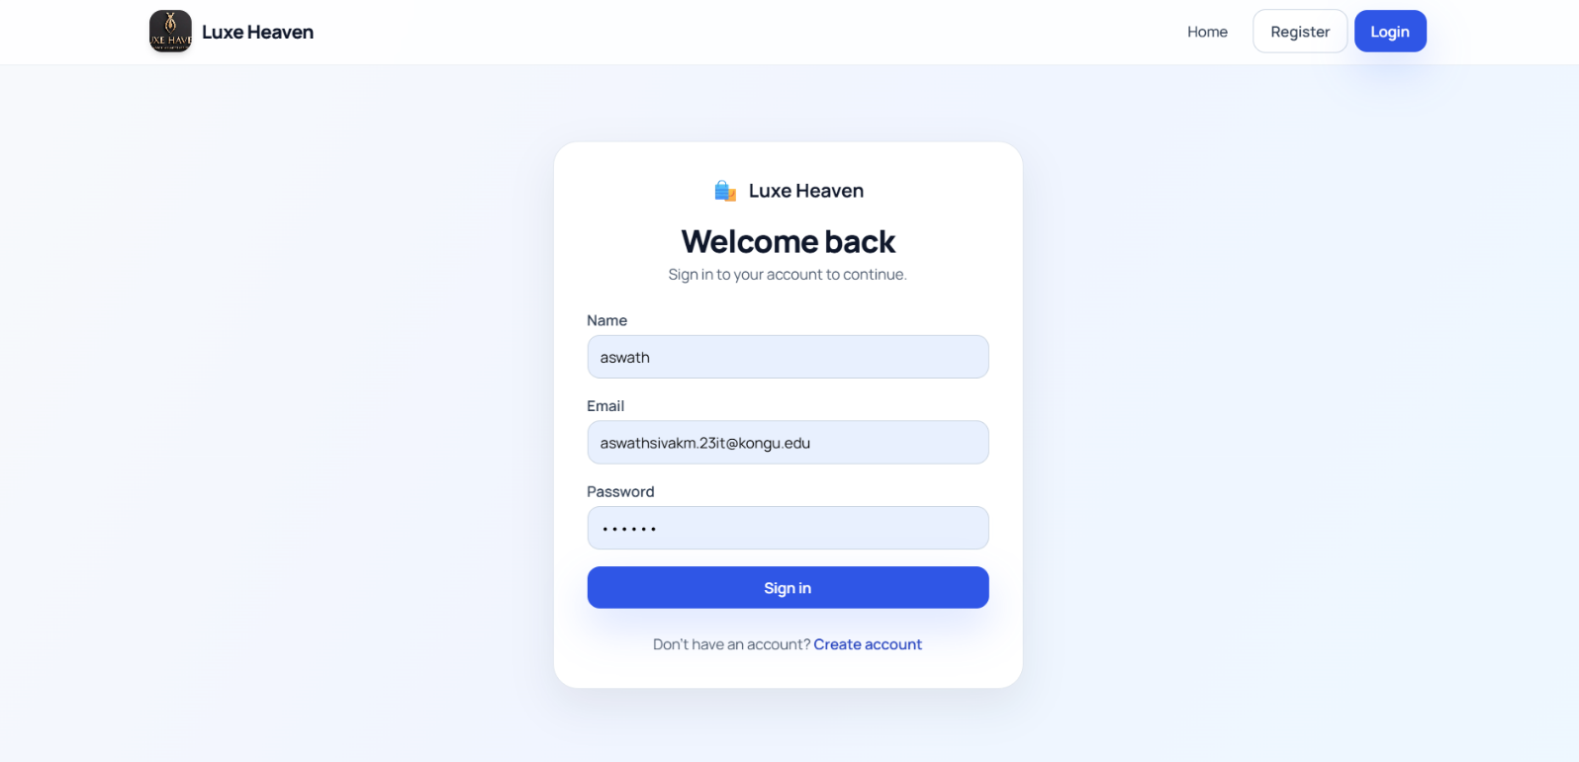

Fig. 1.1 Login Page

Project Management Module

This module enables admins and sellers to manage the product inventory in the Luxe Haven store. Products can be added, updated, or deleted through an intuitive interface, with attributes including name, description, price, size options, stock quantity, and images. 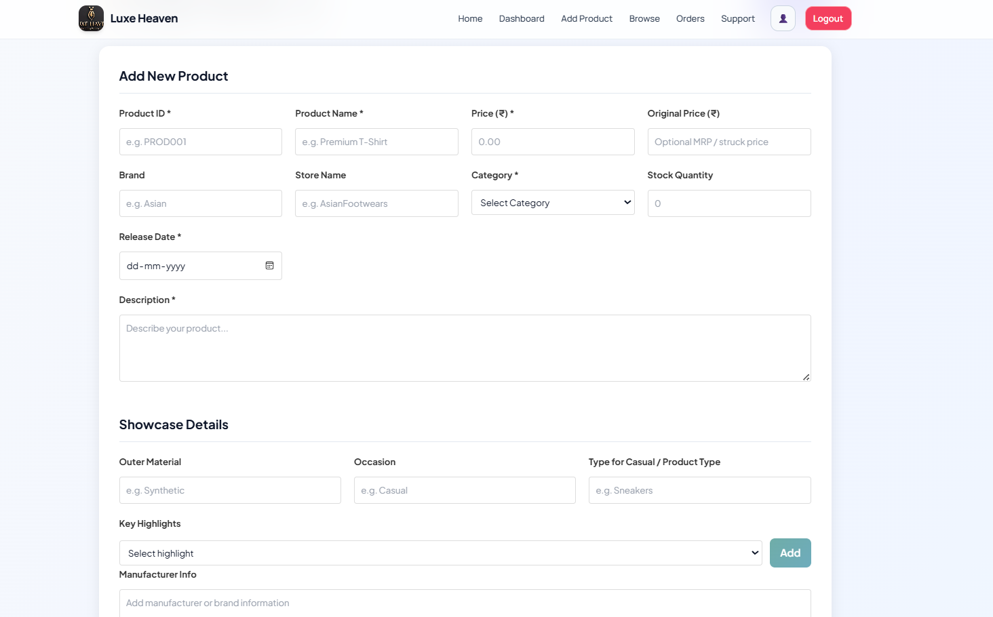

Fig. 1.2 Add new Product Page

Product Browsing and Search Module

This customer-facing module allows users to browse and search through available products in the Luxe-Haven platform. Products are organized by categories with detailed views including specifications, pricing, and availability 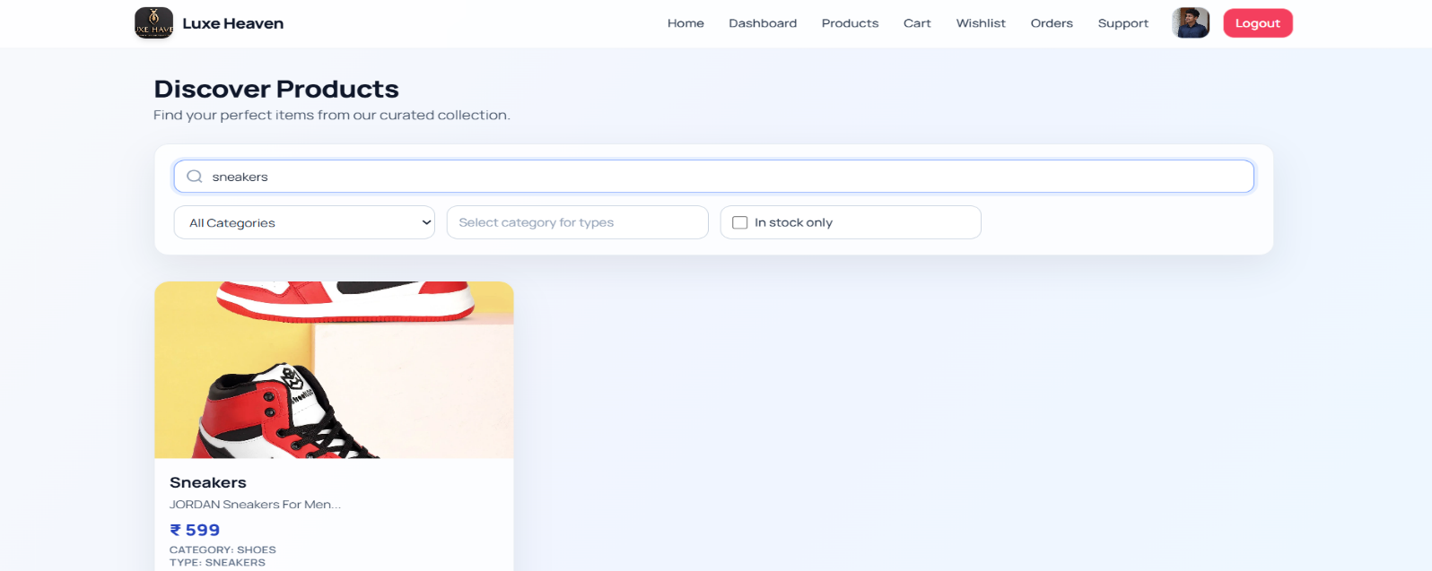
Fig. 1.3 Product Listing Page

Cart and Order Placement Module

This module maintains an audit trail of inventory changes across the Luxe-Haven platform. It tracks stock additions, reductions, and updates for all products, providing transparency for admins and sellers.
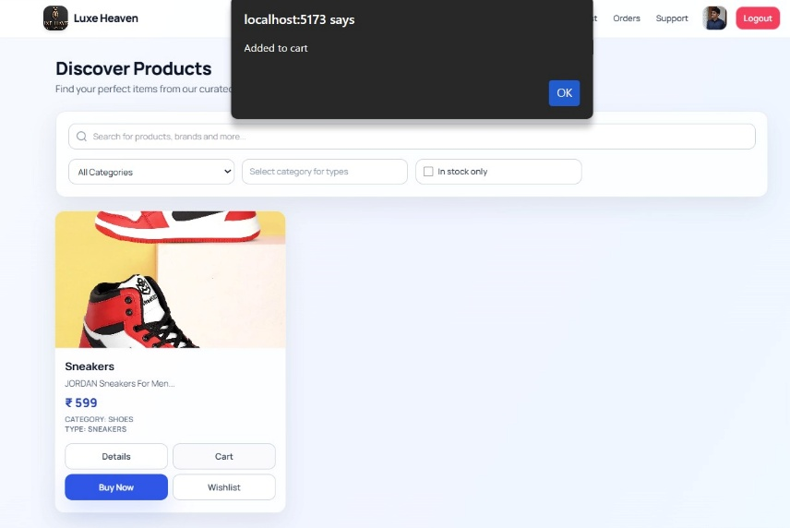
Fig. 1.4 Cart & Order Placement Page

Payment Module
The Payment Screen allows users to review their order details and choose a preferred payment method. It ensures a secure transaction process to complete the purchase successfully.
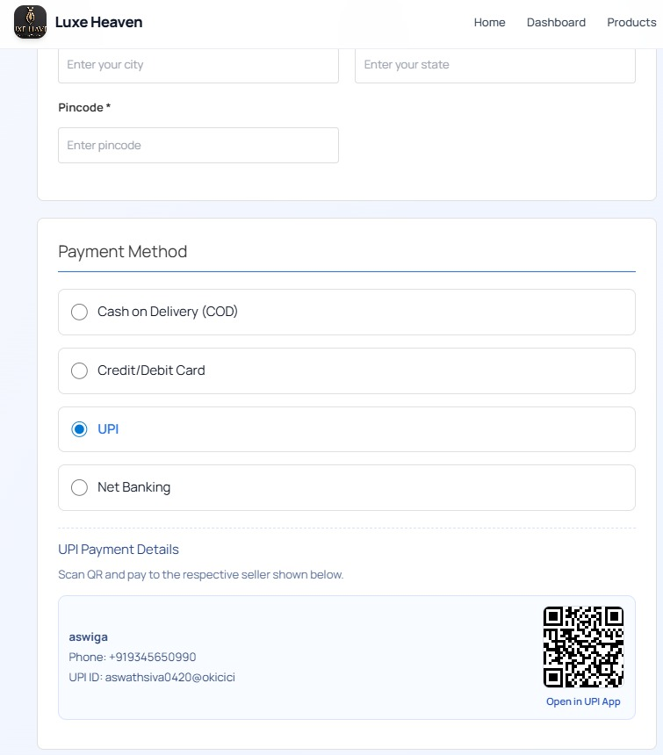
Fig. 1.5 Payment Module

Database Management Module

Database Management module handles data storage and retrieval using database models such as User, Project, and Task. It ensures that all user information, project details, and task records are stored securely and can be accessed whenever required.
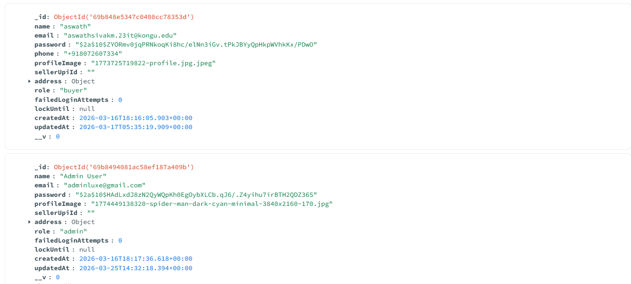
Fig. 1.6 Database Page

Admin Dashboard Module

This administrative module provides system-wide oversight for the Luxe-Haven e commerce platform. Admins can view comprehensive dashboards with order statistics, user management, and product oversight.
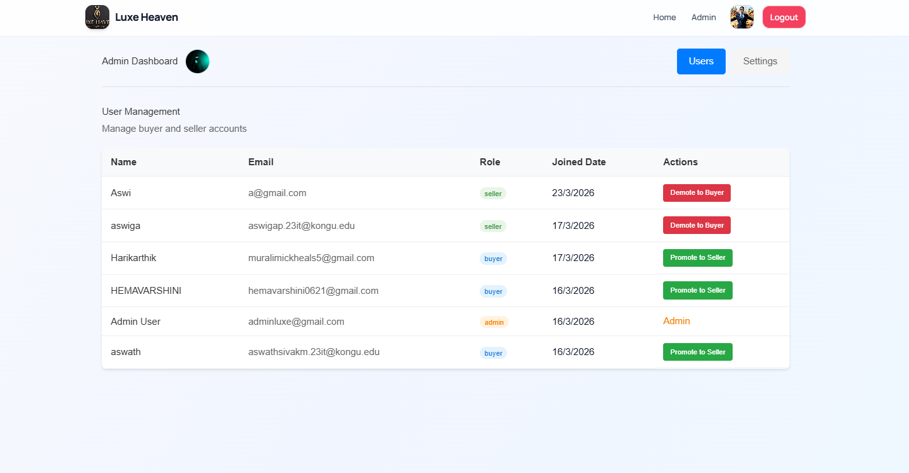
Fig. 1.7 Admin Dashboard Page

CHAPTER 4

RESULTS

The Luxe-Haven E-Commerce App developed for modern retail operations has effectively delivered a comprehensive web-based solution for managing multi-seller product sales and user interactions. It allows users to easily register, log in, explore a diverse range of products with detailed specifications, add items to their cart, manage wishlists, and securely complete purchases with integrated order processing. The backend, powered by Node.js and Express.js, works seamlessly with MongoDB to handle data operations like product listings, user management, order tracking, and support ticket handling in real time. Built using React with Vite, the app offers a consistent and responsive user experience across devices through its clean interface and intuitive navigation, encouraging repeat usage. Role-based functionalities enable buyers to browse and purchase, sellers to manage inventory and track sales, and admins to oversee operations, order status updates, and system configurations, reducing manual work and improving efficiency. Extensive testing confirmed smooth performance, quick response times, and reliable data synchronization. The app enhances customer engagement through features like stock history tracking, quantity-based discounts, and personalized dashboards, fostering loyalty in a competitive market. In terms of long-term value, the application is built with scalability in mind, allowing future enhancements like advanced analytics, payment gateway integrations, multilingual support, and expanded reporting. Overall, the app represents a modern, digital-first approach to e commerce, aligning with growth objectives and setting the foundation for continued expansion in the online retail domain.

CHAPTER 5

CONCLUSION AND FUTURE WORK

The Luxe-Haven E-Commerce App has achieved its core purpose of creating a user friendly, scalable, and efficient multi-seller marketplace platform that simplifies the process of buying and selling diverse products online. By incorporating modern technologies such as React with Vite for a responsive frontend interface, Node.js and Express.js for robust server-side operations, and MongoDB for flexible database management, the app ensures high performance and seamless functionality across all user roles. It streamlines the customer journey from product discovery and wishlist management to secure cart operations and order placement, while also empowering sellers with convenient inventory management tools and admins with comprehensive system oversight and configuration controls. The app's deployment has significantly improved business efficiency by reducing manual intervention through automated order processing, minimizing errors via validation mechanisms, and increasing customer accessibility to a diverse product catalog. It bridges the gap between traditional retail and modern e-commerce, positioning the platform for digital growth and expanded market reach across multiple seller communities.

Looking toward the future, there is substantial potential to incorporate additional features such as AI-based product recommendation engines, advanced order tracking and shipment integration with logistics providers, and comprehensive sales analytics dashboards for sellers and admins. Multi-language and multi-currency support can cater to regional and international audiences, while implementing a robust rating and review system will build trust and transparency among buyers. Furthermore, integrating real-time customer chat support, predictive inventory analytics, social commerce integration, and advanced seller subscription tiers can expand the platform's usability and revenue streams. Mobile app development using React Native would extend accessibility to smartphone users. These enhancements will strengthen customer relationships, drive seller engagement, and support the long-term scalability and adaptability of the application in an evolving digital marketplace, ultimately positioning Luxe-Haven as a leading e-commerce platform.
APPENDIX 1

CODING

App.jsx
import { BrowserRouter, Routes, Route, useLocation } from "react-router-dom";
import Navbar from "./components/Navbar";
import { AnimatePresence, motion } from "framer-motion";

import Home from "./pages/Home";
import Login from "./pages/Login";
import Register from "./pages/Register";
import Products from "./pages/Products";
import ProductDetails from "./pages/ProductDetails";
import Cart from "./pages/Cart";
import Wishlist from "./pages/Wishlist";
import Checkout from "./pages/Checkout";
import Orders from "./pages/Orders";
import BuyerDashboard from "./pages/BuyerDashboard";
import SellerDashboard from "./pages/SellerDashboard";
import SellerProductManagement from "./pages/SellerProductManagement";
import SellerOrderManagement from "./pages/SellerOrderManagement";
import StockHistory from "./pages/StockHistory";
import AdminDashboard from "./pages/AdminDashboard";
import Support from "./pages/Support";
import Profile from "./pages/Profile";

const pageVariants = {
initial: {
opacity: 0,
y: 16,
filter: "blur(6px)",
},
animate: {
opacity: 1,
y: 0,
filter: "blur(0px)",
transition: { duration: 0.4, ease: "easeOut" },
},
exit: {
opacity: 0,
y: -16,
filter: "blur(4px)",
transition: { duration: 0.25, ease: "easeIn" },
},
};

function AnimatedRoutes() {
const location = useLocation();

return (
<AnimatePresence mode="wait">
<motion.div
key={location.pathname}
variants={pageVariants}
initial="initial"
animate="animate"
exit="exit"
>
<Routes location={location}>
<Route path="/" element={<Home />} />
<Route path="/login" element={<Login />} />
<Route path="/register" element={<Register />} />

<Route path="/products" element={<Products />} />
<Route path="/products/:id" element={<ProductDetails />} />
<Route path="/cart" element={<Cart />} />
<Route path="/wishlist" element={<Wishlist />} />
<Route path="/checkout" element={<Checkout />} />
<Route path="/orders" element={<Orders />} />
<Route path="/support" element={<Support />} />
<Route path="/profile" element={<Profile />} />

<Route path="/buyer/dashboard" element={<BuyerDashboard />} />
<Route path="/seller/dashboard" element={<SellerDashboard />} />
<Route path="/seller/products" element={<SellerProductManagement />} />
<Route path="/seller/orders" element={<SellerOrderManagement />} />
<Route path="/seller/stock-history" element={<StockHistory />} />
<Route path="/admin" element={<AdminDashboard />} />
</Routes>
</motion.div>
</AnimatePresence>
}

export default function App() {
return (
<BrowserRouter>
<div className="app-shell">
<Navbar />
<AnimatedRoutes />
</BrowserRouter>
);
}

Home.jsx:
import { useNavigate } from "react-router-dom";
import { motion } from "framer-motion";
import tshirtImage from "../assets/tshirt.avif";
import pantImage from "../assets/pant.jpg";
import sneakersImage from "../assets/sneakers.jpg";

const heroVariants = {
hidden: { opacity: 0, y: 24 },
visible: {
opacity: 1,
y: 0,
transition: { duration: 0.6, ease: "easeOut" },
},
};

const featureCardVariants = {
hidden: { opacity: 0, y: 20 },
visible: (index) => ({
opacity: 1,
y: 0,
transition: { duration: 0.4, delay: index * 0.08, ease: "easeOut" },
}),
};

export default function Home() {
const navigate = useNavigate();
const role = localStorage.getItem("role");

const handleShopNow = () => {
if (role) {
// If logged in, go to products
navigate("/products");
} else {
// If not logged in, go to login
navigate("/login");
}
};

return (
<div className="mx-auto w-full max-w-[1240px] px-4 pb-16 pt-8 md:px-8">
<motion.section
className="relative overflow-hidden rounded-3xl border border-brand-200/70 bg-white p-6 shadow-card md:p-10"
variants={heroVariants}
initial="hidden"
animate="visible"
>
<div className="pointer-events-none absolute inset-0 bg-hero-grid bg-[size:22px_22px] opacity-50" />
<div className="relative grid items-center gap-8 lg:grid-cols-[1.15fr_1fr]">
<div>
<p className="mb-3 inline-flex rounded-full bg-brand-50 px-3 py-1 text-xs font-semibold uppercase tracking-[0.14em] text-brand-700">
Premium Marketplace
</p>
<h1 className="text-3xl font-extrabold leading-tight text-slate-900 md:text-5xl">
Welcome to <span className="text-brand-600">Luxe Haven</span>
</h1>
<p className="mt-4 max-w-xl text-base text-slate-600 md:text-lg">
Discover premium fashion, exclusive deals, and standout picks curated for your personal style.
</p>
<div className="mt-7 flex flex-wrap gap-3">
<button className="ui-btn-primary" onClick={handleShopNow}>Shop Now</button>
{!role && (
<button className="ui-btn-soft" onClick={() => navigate("/register")}>Create Account</button>
)}
</div>
</div>

<div className="grid grid-cols-2 gap-3 sm:gap-4">
{[tshirtImage, pantImage, sneakersImage].map((img, i) => (
<motion.div
key={img}
initial={{ opacity: 0, y: 24 }}
animate={{ opacity: 1, y: 0 }}
transition={{ delay: i * 0.12 + 0.2, duration: 0.35 }}
className={`overflow-hidden rounded-2xl border border-slate-200 bg-slate-100 shadow-md ${i === 2 ? "col-span-2" : ""}`}
>
<img src={img} alt="Collection" className="h-44 w-full object-cover sm:h-52" />
</motion.div>
))}
</div>
</div>
</motion.section>

<section className="mt-10 grid gap-4 sm:grid-cols-2 lg:grid-cols-4">
{[
["🎯", "Wide Selection", "Thousands of products across categories"],
["💰", "Best Prices", "Exclusive deals and smart pricing"],
["🔒", "Secure Shopping", "Protected checkout and data safety"],
["⭐", "Top Rated", "Loved by repeat customers"],
].map(([icon, title, desc], index) => (
<motion.div
key={title}
className="glass-card p-5"
variants={featureCardVariants}
initial="hidden"
whileInView="visible"
viewport={{ once: true, amount: 0.3 }}
custom={index}
>
<div className="text-2xl">{icon}</div>
<h3 className="mt-2 text-lg font-bold text-slate-900">{title}</h3>
<p className="mt-1 text-sm text-slate-600">{desc}</p>
</motion.div>
))}
</section>

<section className="mt-12">
<h2 className="text-2xl font-extrabold text-slate-900">Shop by Category</h2>
<div className="mt-5 grid gap-4 sm:grid-cols-2 lg:grid-cols-4">
{[
["👔", "Men's Fashion", "Premium clothing", "Men"],
["👗", "Women's Fashion", "Elegant styles", "Women"],
["📱", "Electronics", "Latest gadgets", "Electronics"],
["🏠", "Home & Living", "Furniture and decor", "Home"],
].map(([icon, title, desc, cat]) => (
<motion.button
key={title}
whileHover={{ y: -6, scale: 1.01 }}
transition={{ type: "spring", stiffness: 250, damping: 22 }}
onClick={() => navigate(role ? `/products?category=${cat}` : "/login")}
className="glass-card group p-5 text-left"
>
<div className="text-2xl">{icon}</div>
<h3 className="mt-2 text-lg font-bold text-slate-900 group-hover:text-brand-700">{title}</h3>
<p className="text-sm text-slate-600">{desc}</p>
</motion.button>
))}
</div>
</section>

{!role && (
<motion.section
className="mt-12 rounded-3xl border border-brand-200 bg-gradient-to-r from-brand-600 to-brand-800 p-8 text-white shadow-card"
initial={{ opacity: 0, y: 18 }}
whileInView={{ opacity: 1, y: 0 }}
viewport={{ once: true, amount: 0.4 }}
transition={{ duration: 0.45 }}
>
<h2 className="text-2xl font-extrabold">Ready to Start Shopping?</h2>
<p className="mt-2 text-brand-100">Join thousands of happy customers and discover amazing products.</p>
<div className="mt-5 flex flex-wrap gap-3">
<button className="rounded-xl bg-white px-4 py-2.5 text-sm font-bold text-brand-700" onClick={() => navigate("/register")}>
Sign Up Free
</button>
<button className="rounded-xl border border-brand-300/60 bg-brand-700/40 px-4 py-2.5 text-sm font-bold text-white" onClick={() => navigate("/login")}>
Sign In
</button>
</div>
</motion.section>
)}
</div>
);
}

Products.jsx:
import { useEffect, useState } from "react";
import { useNavigate } from "react-router-dom";
import api from "../services/api";
import { motion } from "framer-motion";
import { buildUploadUrl } from "../utils/assetUrl";

const gridVariants = {
hidden: { opacity: 0 },
visible: {
opacity: 1,
transition: { staggerChildren: 0.04, delayChildren: 0.1 },
},
};

const cardVariants = {
hidden: { opacity: 0, y: 16 },
visible: {
opacity: 1,
y: 0,
transition: { duration: 0.3, ease: "easeOut" },
},
};

export default function Products() {
const [products, setProducts] = useState([]);
const [search, setSearch] = useState("");
const [category, setCategory] = useState("");
const [subCategory, setSubCategory] = useState("");
const [inStockOnly, setInStockOnly] = useState(false);
const navigate = useNavigate();
const token = localStorage.getItem("token");

const CATEGORY_OPTIONS = [
"",
"Tshirt",
"Pants",
"Shoes",
"Men",
"Women",
"Electronics",
"Home",
"Sports",
"Books",
"Toys",
"Accessories",
"Other",
];

const SUBCATEGORY_OPTIONS = {
Tshirt: ["Crew Neck", "V-Neck", "Polo", "Tank Top"],
Pants: ["Jeans", "Chinos", "Shorts", "Track Pants"],
Shoes: ["Sneakers", "Boots", "Sandals", "Loafers"]
};

useEffect(() => {
const controller = new AbortController();

const fetchProducts = async () => {
try {
const res = await api.get("/products", {
signal: controller.signal,
params: {
search: search || undefined,
category: category || undefined,
subCategory: subCategory || undefined,
inStock: inStockOnly ? "true" : undefined
}
});
setProducts(res.data);
} catch (err) {
if (err.name !== "CanceledError" && err.name !== "AbortError") {
console.error(err);
}
}
};

const timer = setTimeout(fetchProducts, 250);
return () => {
clearTimeout(timer);
controller.abort();
};
}, [search, category, subCategory, inStockOnly]);

const addToCart = async (id) => {
if (!token) {
alert("Please login to add items to cart");
navigate("/login");
return;
}
try {
await api.post("/cart/add", { productId: id });
alert("Added to cart");
} catch (error) {
console.error("Error adding to cart:", error);
alert(error.response?.data?.msg || "Error adding to cart");
}
};

const addToWishlist = async (id) => {
if (!token) {
alert("Please login to add items to wishlist");
navigate("/login");
return;
}
try {
await api.post("/wishlist/add", { productId: id });
alert("Added to wishlist");
} catch (error) {
console.error("Error adding to wishlist:", error);
alert(error.response?.data?.msg || "Error adding to wishlist");
}
};

const buyNow = (product) => {
if (!token) {
alert("Please login to buy");
navigate("/login");
return;
}
navigate("/checkout", {
state: {
items: [{
productId: product,
quantity: 1,
subtotal: product.price
}],
total: product.price,
fromCart: false
}
});
};

const openProductDetails = (id) => {
navigate(`/products/${id}`);
};

const role = localStorage.getItem("role");

return (
<div className="mx-auto w-full max-w-[1240px] px-4 pb-16 pt-8 md:px-8">
<div className="mb-6">
<h2 className="text-3xl font-extrabold tracking-tight text-slate-900">Discover Products</h2>
<p className="mt-1 text-slate-600">Find your perfect items from our curated collection.</p>
</div>

<div className="glass-card mb-8 p-4 md:p-5">
<div className="relative mb-4">
<input
type="text"
className="ui-input pl-10"
placeholder="Search for products, brands and more..."
value={search}
onChange={(e) => setSearch(e.target.value)}
/>
<svg className="pointer-events-none absolute left-3 top-1/2 h-5 w-5 -translate-y-1/2 text-slate-400" viewBox="0 0 24 24" fill="none" stroke="currentColor" strokeWidth="2">
<circle cx="11" cy="11" r="8"></circle>
<path d="m21 21-4.35-4.35"></path>
</svg>
</div>

<div className="grid gap-3 sm:grid-cols-2 lg:grid-cols-4">
<select
className="ui-input"
value={category}
onChange={(e) => {
setCategory(e.target.value);
setSubCategory("");
}}
>
<option value="">All Categories</option>
{CATEGORY_OPTIONS.filter((c) => c).map((cat) => (
<option key={cat} value={cat}>{cat}</option>
))}
</select>

{SUBCATEGORY_OPTIONS[category] ? (
<select className="ui-input" value={subCategory} onChange={(e) => setSubCategory(e.target.value)}>
<option value="">All Types</option>
{SUBCATEGORY_OPTIONS[category].map((type) => (
<option key={type} value={type}>{type}</option>
))}
</select>
) : (
<div className="ui-input flex items-center text-slate-400">Select category for types</div>
)}

<label className="flex items-center gap-2 rounded-xl border border-slate-300 bg-white px-3 py-2.5 text-sm font-medium text-slate-700">
<input
type="checkbox"
checked={inStockOnly}
onChange={(e) => setInStockOnly(e.target.checked)}
className="h-4 w-4 rounded border-slate-300"
/>
In stock only
</label>
</div>
</div>

{products.length === 0 ? (
<div className="glass-card p-8 text-center text-slate-600">No products available yet. Check back later.</div>
) : (
<motion.div className="grid gap-5 sm:grid-cols-2 lg:grid-cols-3" variants={gridVariants} initial="hidden" animate="visible">
{products.map((p) => (
<motion.div
className="glass-card cursor-pointer"
key={p._id}
variants={cardVariants}
whileHover={{ y: -8, scale: 1.01 }}
transition={{ type: "spring", stiffness: 260, damping: 22 }}
onClick={() => openProductDetails(p._id)}
role="button"
tabIndex={0}
onKeyDown={(e) => {
if (e.key === "Enter" || e.key === " ") {
e.preventDefault();
openProductDetails(p._id);
}
}}
>
<div className="h-56 overflow-hidden rounded-t-2xl bg-slate-100">
<img
src={buildUploadUrl(`uploads/${p.image}`)}
alt={p.name}
className="h-full w-full object-cover"
onError={(e) => {
e.target.src = "https://via.placeholder.com/300x300?text=No+Image";
}}
/>
</div>

<div className="p-4">
<h4 className="text-lg font-bold text-slate-900">{p.name}</h4>
<p className="mt-1 text-sm text-slate-600">{p.description?.substring(0, 70)}...</p>
<p className="mt-2 text-xl font-extrabold text-brand-700">₹ {p.price}</p>
{p.category && <p className="mt-1 text-xs font-semibold uppercase tracking-wide text-slate-500">Category: {p.category}</p>}
{p.subCategory && <p className="text-xs font-semibold uppercase tracking-wide text-slate-500">Type: {p.subCategory}</p>}

{p.stockQuantity <= 0 && (
<div className="mt-2 inline-flex rounded-full bg-rose-100 px-3 py-1 text-xs font-bold text-rose-700">Out of stock</div>
)}
{p.stockQuantity > 0 && p.stockQuantity < 5 && (
<div className="mt-2 inline-flex rounded-full bg-amber-100 px-3 py-1 text-xs font-bold text-amber-700">Only {p.stockQuantity} left</div>
)}

{role === "buyer" || role === "user" || !role ? (
<div className="mt-4 grid grid-cols-2 gap-2 pb-1">
<button
className="ui-btn-soft w-full px-2"
onClick={(e) => {
e.stopPropagation();
openProductDetails(p._id);
}}
title="View Details"
>
Details
</button>

<button
className="ui-btn-soft w-full px-2"
onClick={(e) => {
e.stopPropagation();
addToCart(p._id);
}}
disabled={p.stockQuantity <= 0}
title="Add to Cart"
>
Cart
</button>

<button
className="ui-btn-primary w-full px-2"
onClick={(e) => {
e.stopPropagation();
buyNow(p);
}}
disabled={p.stockQuantity <= 0}
title="Buy Now"
>
Buy Now
</button>

<button
className="ui-btn-soft w-full px-2"
onClick={(e) => {
e.stopPropagation();
addToWishlist(p._id);
}}
disabled={p.stockQuantity <= 0}
title="Add to Wishlist"
>
Wishlist
</button>
</div>
) : (
<div className="mt-4 inline-flex rounded-full bg-slate-100 px-3 py-1 text-xs font-semibold text-slate-500">View only</div>
)}
</div>
</motion.div>
))}
</motion.div>
)}
</div>
);
}

REFERENCES

    - React Documentation - Meta (Facebook), https://react.dev/
    - Vite Documentation - Vite Team, https://vitejs.dev/
    - Tailwind CSS Documentation - Tailwind Labs, https://tailwindcss.com/docs
    - Framer Motion Documentation - Framer, https://www.framer.com/motion/
    - Axios Documentation - Axios, https://axios-http.com/docs/
    - React Router DOM Documentation - React Training, https://reactrouter.com/
    - QRCode.react Documentation - zpao, https://github.com/zpao/qrcode.react
    - Node.js Documentation - OpenJS Foundation, https://nodejs.org/en/docs
    - Express.js Guide - Express.js Official Site, https://expressjs.com/
    - MongoDB Manual - MongoDB Inc., https://www.mongodb.com/docs/manual/
    - Github Link:https://github.com/AswathSiva2005/Luxe-Haven
    - Github Link:https://github.com/ASWIGA/luxe-Haven.git

